Missing at Random (MAR) Analysis Report
Generated on: 2026-04-27 03:54:27
Dataset: 347,749 rows × 14 columns

1. Executive Summary
• Total missing values: 312 (0.01% of all data)
• Variables with missing data: 2 out of 14
• MAR supported for: 2 variables

2. Dataset Overview
Metric | Value
Number of Rows | 347,749
Number of Columns | 14
Total Missing Values | 312
Overall Missing Rate | 0.01%

3. Missing Data Summary
Variable | Data Type | Missing Count | Missing %
Birth_Order | str | 221 | 0.06%
Race_of_Mother | str | 91 | 0.03%

4. Missing at Random (MAR) Analysis Results

4.1 Variable: Birth_Order
Missing Statistics:
• Missing values: 221 (0.06%)
• Data type: str
MAR Determination: YES - Missing at Random supported
Missingness in "Birth_Order" is significantly associated with 2 other observed variable(s) in the dataset, satisfying the MAR condition.
- Associated Variables:
Associated Variable | Type | Statistical Test | P-value
Birth_Order 2.0 | numerical | Mann-Whitney U | 0.0000
Age of Mother | numerical | Mann-Whitney U | 0.0000

4.2 Variable: Race_of_Mother
Missing Statistics:
• Missing values: 91 (0.03%)
• Data type: str
MAR Determination: YES - Missing at Random supported
Missingness in "Race_of_Mother" is significantly associated with 1 other observed variable(s) in the dataset, satisfying the MAR condition.
- Associated Variables:
Associated Variable | Type | Statistical Test | P-value
Age of Mother | numerical | Mann-Whitney U | 0.0001

5. Missing Data Visualizations
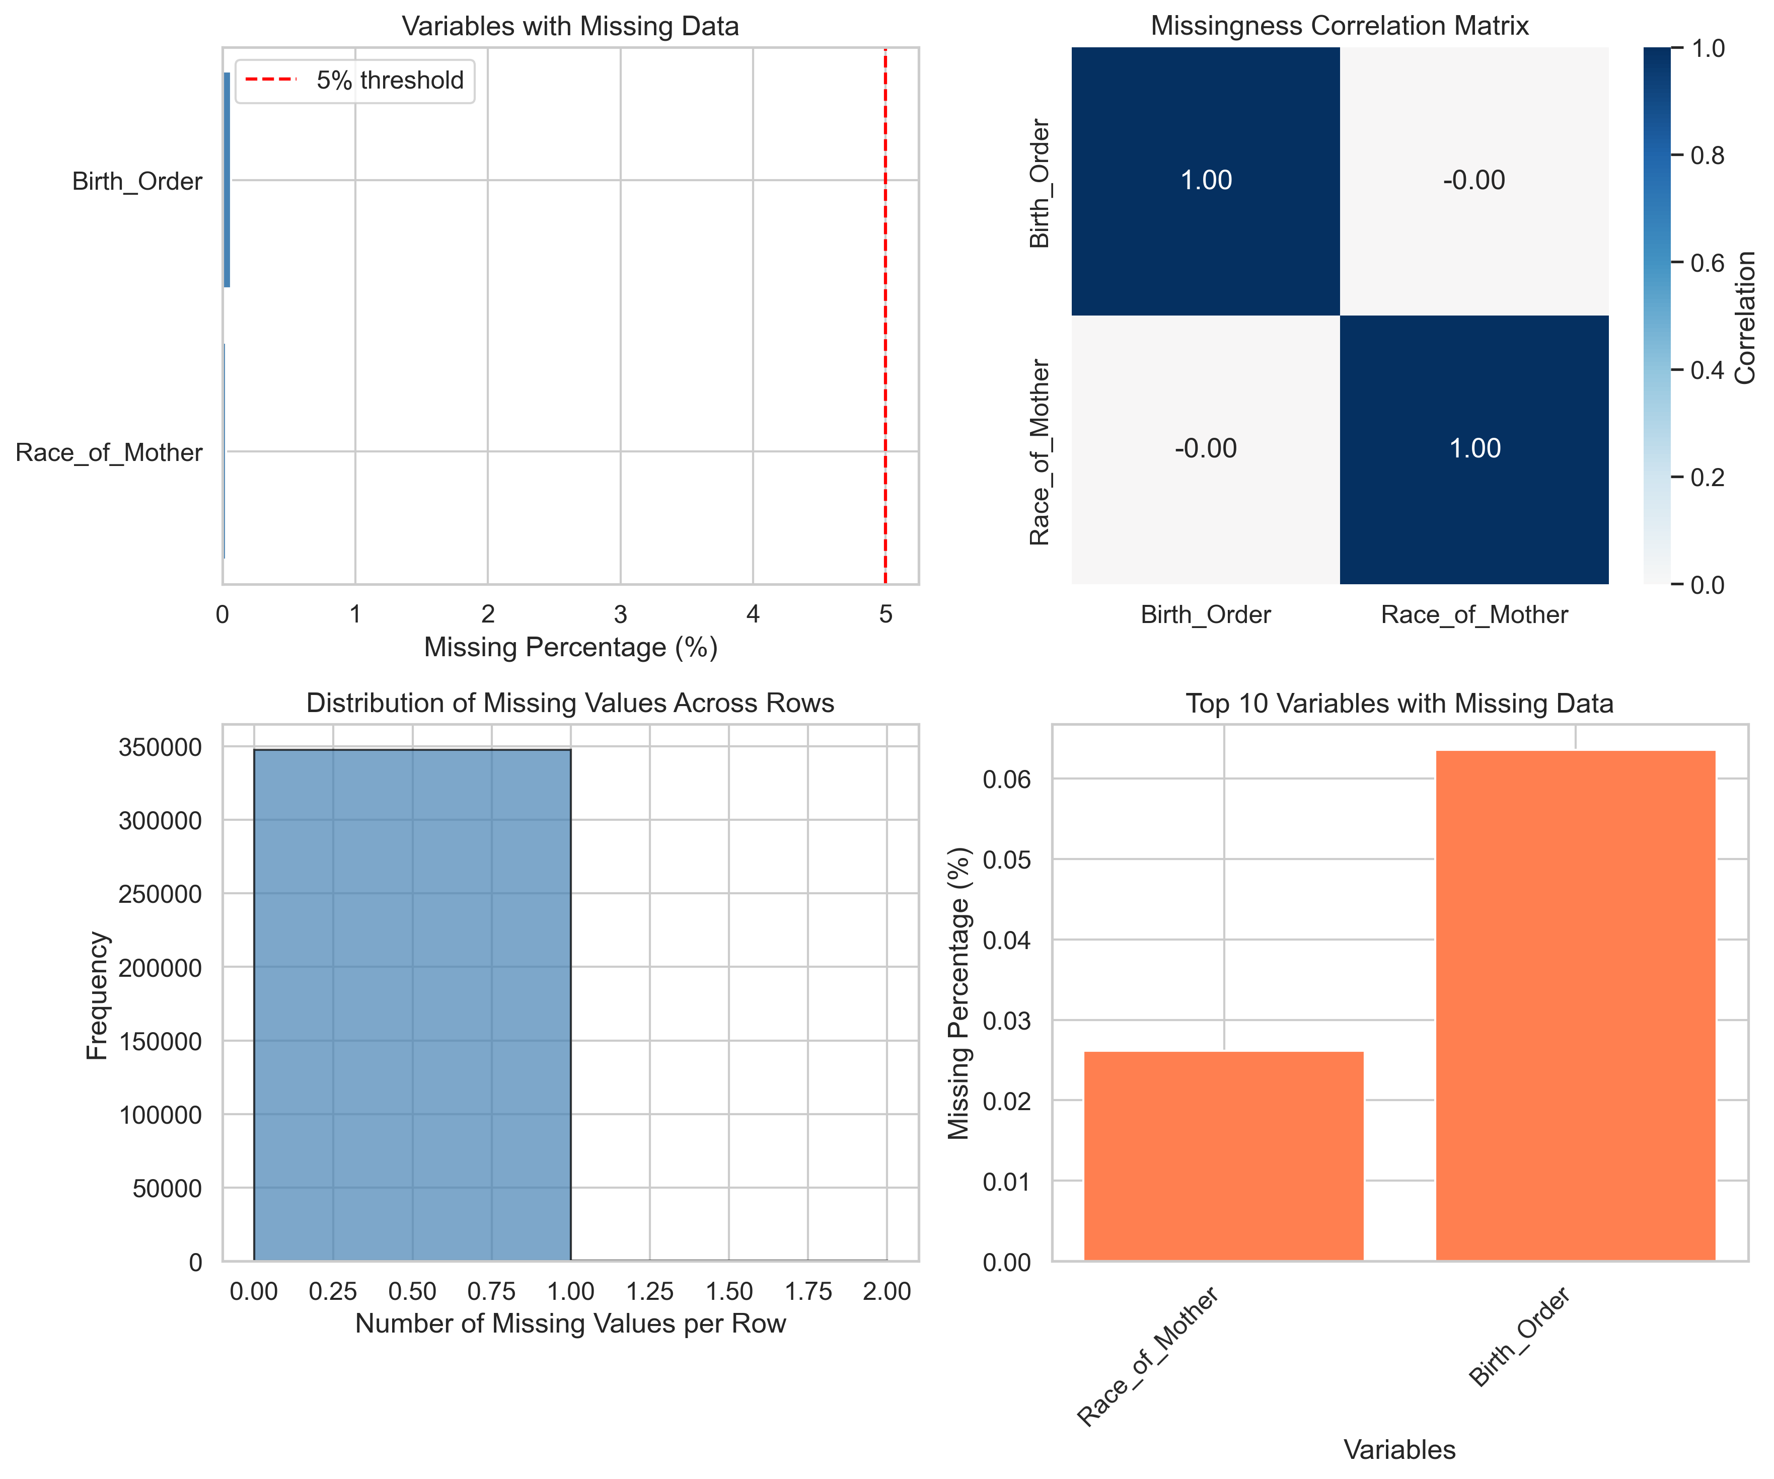
Figure 1: Missing Data Visualizations

6. Recommendations for Missing Data Handling

For MAR Variables:
- Since missingness in these variables depends on observed data, use:
- Multiple Imputation by Chained Equations (MICE)
- Full Information Maximum Likelihood (FIML)
- Expectation-Maximization (EM) Algorithm
Variables to impute: Birth_Order, Race_of_Mother

7. Conclusion
Based on the analysis, 2 out of 2 variable(s) with missing data demonstrate MAR patterns. This indicates that missingness is systematically related to observed variables, making multiple imputation an appropriate strategy.
Overall missing data rate is 0.01%, which is low and requires appropriate handling to avoid biased results.

8. Appendix: Detailed Statistics

Complete MAR Results
Variable | MAR Supported | Number of Associations
Birth_Order | Yes | 2
Race_of_Mother | Yes | 1

